로컬 설치 환경 구성

1. 크롬브라우저 쿠키 허용
2. JDK 13_2 설치

<https://www.oracle.com/java/technologies/javase/jdk13-archive-downloads.html>

접속 후 개인 오라클 계정으로 로그인

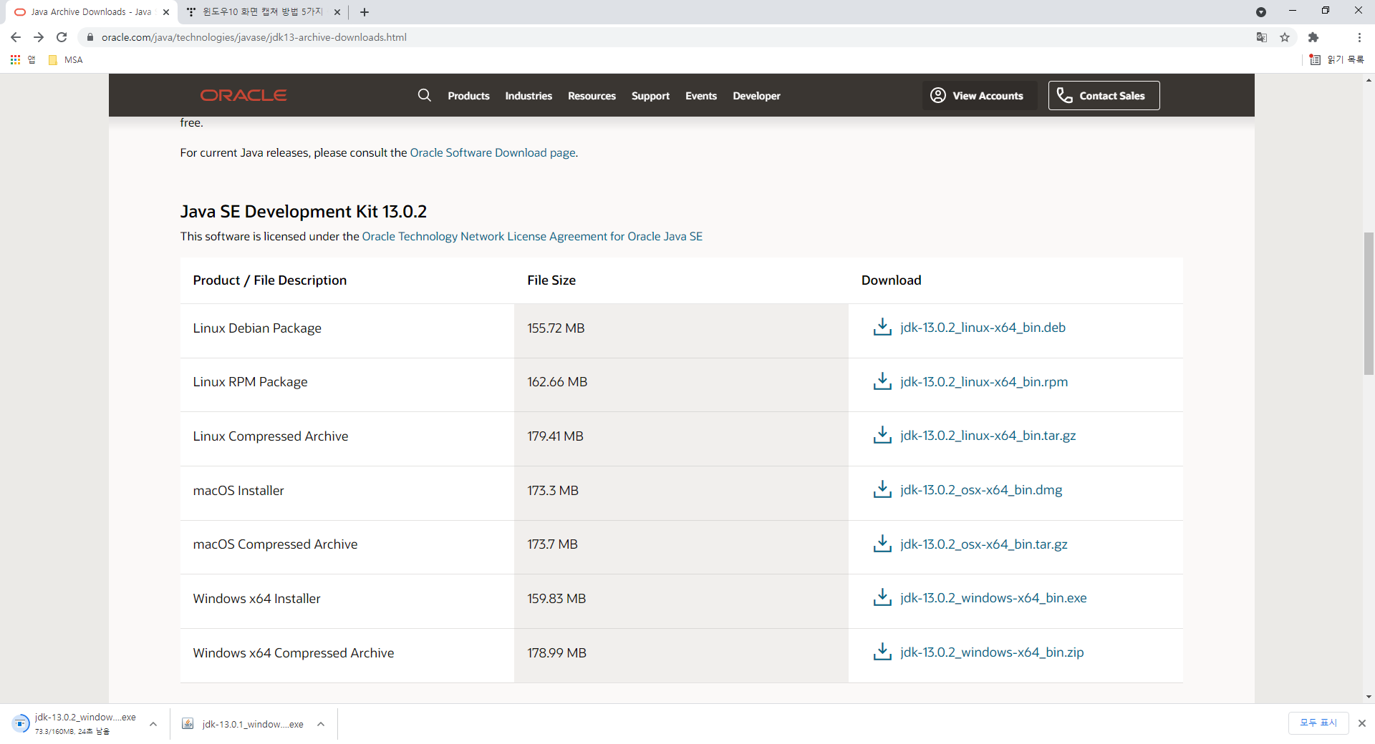

설치 과정 및 설정 : <https://jhnyang.tistory.com/224> 참고

1. Httpie 설치

파이썬 3.9.7 다운로드 : https://www.python.org/ftp/python/3.9.7/python-3.9.7-amd64.exe

설치 과정 및 설정

:<https://github.com/TheOpenCloudEngine/uEngine-cloud/wiki/Httpie-%EC%84%A4%EC%B9%98> 참고

1. VSCode 설치

다운로드 : [https://code.visualstudio.com/download#](https://code.visualstudio.com/download)

Java 설치 경로 설정 : <https://niceman.tistory.com/198>

1. Kafka 설치

<https://kafka.apache.org/downloads>

Scala 2.13  - [kafka_2.13-2.8.0.tgz](https://www.apache.org/dyn/closer.cgi?path=/kafka/2.8.0/kafka_2.13-2.8.0.tgz)  다운로드

* zookeeper실행

cd C:\kafka\bin\windows

zookeeper-server-start.bat ../../config/zookeeper.properties

zookeeper-server-stop.bat ../../config/zookeeper.properties

* kafka server실행
* cd C:\kafka\bin\windows

kafka-server-start.bat ../../config/server.properties

kafka-server-stop.bat ../../config/server.properties

* topic 생성

kafka-topics.bat --create --zookeeper localhost:2181 --replication-factor 1 --partitions 1 --topic deliverymall

* topic 목록 조회

kafka-topics.bat --list --zookeeper localhost:2181

* kafka메시지 등록

kafka-console-producer.bat --broker-list localhost:9092 --topic deliverymall

* kafka메시지 조회

kafka-console-consumer.bat --bootstrap-server localhost:9092 --topic store --from-beginning

* 참고

Error : <https://knowledge.informatica.com/s/article/617840?language=en_US>

1. Maven 3.8.2 설치

다운로드 : <https://maven.apache.org/download.cgi>

설치 과정 및 설정 : <http://34.117.35.195/operation/introduction/util-and-tool/> 참조

1. 도커 설치

다운로드 : <https://docs.docker.com/desktop/windows/install/>

WSL 2 installation is incomplete에러 해결 : https://blog.nachal.com/1691

설치 과정 및 설정 : <https://steemit.com/kr/@mystarlight/docker> 참조

1. Kubectl 설치

<https://kubernetes.io/ko/docs/tasks/tools/install-kubectl-windows/>

1. Minikube 설치

<https://minikube.sigs.k8s.io/docs/start/>

minikube start

kubectl get po –A or minikube kubectl -- get po –A

minikube dashboard

minikube stop

1. Azure Cli 설치

<https://docs.microsoft.com/en-us/cli/azure/install-azure-cli-windows?tabs=azure-cli>

Windows 버전 설치 함

1. Azure 명령어
2. Maven 빌드 및 Spring boot run
   1. Apply

cd C:\Lv2Assessment\Source\StudentApply\Apply

mvn spring-boot:run

* 1. Pay

cd C:\Lv2Assessment\Source\StudentApply\Pay

mvn spring-boot:run

* 1. Delivery

cd C:\Lv2Assessment\Source\StudentApply\Delivery

mvn spring-boot:run

* 1. MyPage

cd C:\Lv2Assessment\Source\StudentApply\MyPage

mvn spring-boot:run

* 1. GateWay

cd C:\Lv2Assessment\Source\StudentApply\gateway

mvn spring-boot:run

1. 테스트
   1. 조회

http localhost:8081/applies

http localhost:8082/pays

http localhost:8083/deliveries

http localhost:8084/myPages

http localhost:8088/applies

* 1. apply 등록

http POST localhost:8081/applies studentId="student1" studentName="홍길동1" bookId="book1" bookName="bookName1" qty=10 amount=1000 applyStatus="Apply" address="ABC"

* 1. apply 삭제

http DELETE localhost:8081/applies/2

* 1. Port 오픈 조회

netstat -an | findstr 808